# Convolution

Convolution is an important concept in a lot of different fields as well in the field of signal processing and analysis. Convolution is able to create an output out of any input signal and an impulse response.

|  |  |  |
| --- | --- | --- |
|  |  |  |
|  | X |  |
|  |  |  |

In convolution a calculation is performed at a pixel which is set by the sum of the neighboring pixels.  
This could be setup as a lot of things + sign, 3x3, 5x5 or even bigger. The size of the matrix has a couple tells. First off the smaller ones take less computing to process. Second the bigger ones get higher quality results.

|  |  |  |
| --- | --- | --- |
|  |  |  |
|  | X |  |
|  |  |  |

Example neighborhoods

The square or neighborhood is also known as the convolution kernel. And the size of this kernel will dictate the calculations that will have to happen.   
Then there is the impulse response which is what the system is going to run against the current values and would be better named as the actual filter.  
A certain setting of the impulse could be a low pass filter where in a different one could be a high pass filter or many different settings.  
  
Convolution definition comes out of the mathematical domain.   
And its equation is as follows:  
Definition of 1D Convolution   
x[n] is an input signal.  
h[n] is the impulse response.  
y[n] is output.  
* is the notation for convolution.  
· is multiple.  
  
Important is that we multiply x[k] by the terms of time-shifted h[n] and add them up.

Key to understanding convolution is understanding how the impulses are being handled.

## 1D convolution

For this example we are given the following:  
*x*[n] = { 3, 4, 5 }  🡨 is an input signal  
*h*[n] = { 2, 1 } 🡨 is the impulse response

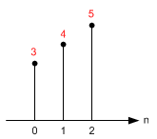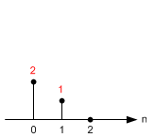

Impulse Response: h[n]

Input: x[n]

And with this information we are going to calculate the output step for step.  
For the calculation of a straight line we don’t have to think about the kernel just yet.

y[0] = x[k] · h[0-k] = x[0] · h[0] = 3·2 = 6  
y[1] = x[k] · h[1-k] = x[0] ·h[1-0] + x[1] ·h[1-1] = 3·1+4·2 = 11  
y[2] = x[k] · h[2-k] = x[0] ·h[2-0] + x[1] ·h[2-1]   
 + x[2] ·h[2-2] = 3·0+4·1+5·2 = 14  
y[3] = x[k] · h[3-k] = x[0] ·h[3-0] + x[1] ·h[3-1]   
 + x[2] ·h[3-2] + x[3] ·h[3-3] = 0+0+5x1+0 = 5

y[4] = x[k] · h[4-k] = x[0] ·h[4-0] + x[1] ·h[4-1]  
 + x[2] ·h[4-2] + x[3] ·h[4-3]  
 + x[4] ·h[4-4] = 0+0+0+0+0 = 0

As you might as well have spotted there is no use to continue after y[4] they will all be 0’s.

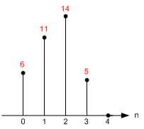  
Output: y[n]

## 2D Convolution

Keep in mind that everything is based on column and row.   
Just to be clear a column is horizontal and a row is vertical.   
In this demonstration I deal with the edges by zero filling the edge which in an actual situation would give you a darker edge around the picture its being applied too.

Notice that the origin of impulse response is always centered. (h[0,0] is located at the center of the sample of the kernel, not the first element!)

Let's start calculate each sample of the output one by one.

First, flip the kernel, in both horizontal and vertical direction. Then, move it over the input.

The accumulation (adding these 9 multiplications) is the last thing to do to find out the output value.

Note that the matrices are referenced here as [column, row], not [row, column]. M is horizontal (column) direction and N is vertical (row) direction.  
The following example is the Sobel filter,  
To not confuse you I have already flipped the impulse response.

For this example we are using the following:

|  |  |  |
| --- | --- | --- |
| 1 | 2 | 3 |
| 4 | 5 | 6 |
| 7 | 8 | 9 |

|  |  |  |
| --- | --- | --- |
| -1 | -2 | -1 |
| 0 | 0 | 0 |
| 1 | 2 | 1 |

Input x[n] Impulse Response: h[n]

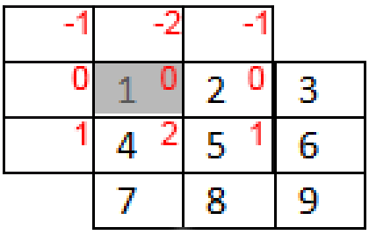 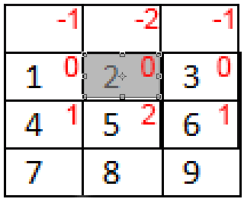 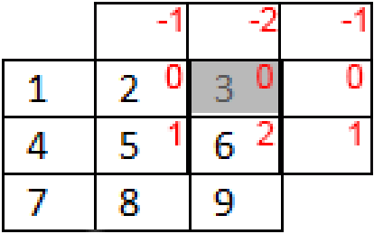

Y[0,0] Y[0,1] y[0,2]

The impulse response is always centered around the value that we want to change.

This means that the value that your are calculating the value of h[0,0] is centered on that value.( This is one in the example).

However for the value x[0,0] is almost the first value top left. (in this example that is 1.)

For calculating y[0,0] we need the following.

Y[0,0] =   
 X[-1,-1] · h[1,1] + X[0,-1] · h[0,1] + X[1,-1] · h[-1,1]   
+ X[-1,0] · h[1,0] + X[0,0] · h[0,0] + X[1,0] · h[-1,0]  
+ X[-1,1] · h[1,-1] + X[0,1] · h[0,-1] + X[1,1] · h[-1,-1]

0x1 + 0x2 + 0x1 0x-1 0x-2 0x1  
+ 0x0 + 1x0 + 2X0 0x0 0x0 0x0  
+ 0x-1 + 4x-2 + 5x-1 = -13 0x1 4x2 5x1

Y[1,0] =   
 X[0,-1] · h[1,1] + X[1,-1] · h[0,1] + X[2,-1] · h[-1,1]

+ X[0,0] · h[1,0] + X[1,0] · h[0,0] + X[2,0] · h[-1,0]

+ X[0,1] · h[1,-1] + X[1,1] · h[0,-1] + X[2,1] · h[-1,-1]

0x1 + 0x2 + 0x1  
+ 1x0 + 2x0 + 3x0

+ 4x-1 + 5x-2 + 6x-1 = -20

Y[2,0] =   
 X[1,-1] · h[1,1] + X[2,-1] · h[0,1] + X[3,-1] · h[-1,1]

+ X[1,0] · h[1,0] + X[2,0] · h[0,0] + X[3,0] · h[-1,0]

+ X[1,1] · h[1,-1] + X[2,1] · h[0,-1] + X[3,1] · h[-1,-1]

0x1 + 0x2 + 0x1  
+ 2x0 + 3x0 + 0x0

+ 5x-1 + 6x-2 + 0x-1 = -17

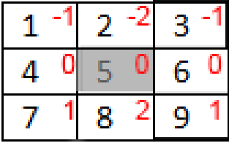

Y[1,1] =   
 X[0,0] · h[1,1] + X[1,0] · h[0,1] + X[2,0] · h[-1,1]

+ X[0,1] · h[1,0] + X[1,1] · h[0,0] + X[2,1] · h[-1,0]   
+ X[0,2] · h[1,-1] + X[1,2] · h[0,-1] + X[2,2] · h[-1,-1]

1x1 + 2x2 + 3x1  
4x0 + 5x0 + 6x0

7x-1 + 8x-2 + 9x-2 = -24 =

So far we have calculated the following values and if you see the pattern in the calculations you can finish the rest which gives you the end result.

|  |  |  |
| --- | --- | --- |
| -13 | -20 | -17 |
|  | -24 |  |
|  |  |  |

|  |  |  |
| --- | --- | --- |
| -13 | -20 | -17 |
| -18 | -24 | -18 |
| 13 | 20 | 17 |

Input x[n] Impulse Response: h[n]

## Examples of convolution using techniques

* Edge Detection (with high or low frequencies)
* Noise removal
* Smoothing
* Image sharpening
* Zooming

High-pass and low=pass filters are the simplest forms of filters, and they are relatively easy to design to specifications. However filters used for zooming and noise elimination are low pass filters.  
Edge detection or image sharpening are high pass filters.

Low pass  
Left side untouched – right side has a low pass (median) filter ran through it.  
  
Most common impulse responses:

|  |  |  |  |  |  |  |
| --- | --- | --- | --- | --- | --- | --- |
| 1 | 1 | 1 |  | 1 | 2 | 1 |
| 1 | 2 | 1 |  | 2 | 4 | 2 |
| 1 | 1 | 1 |  | 1 | 2 | 1 |

Average low pass More aggressive low pass

Example pass:

|  |  |  |  |  |  |  |  |  |  |  |
| --- | --- | --- | --- | --- | --- | --- | --- | --- | --- | --- |
| 1 | 2 | 3 |  | 1 | 1 | 1 |  | 13 | 23 | 19 |
| 4 | 5 | 6 |  | 1 | 2 | 1 |  | 31 | 50 | 38 |
| 7 | 8 | 9 |  | 1 | 1 | 1 |  | 31 | 47 | 37 |

Input x[n] Impulse Response: h[n] Output y[n]

Pros:  
Eliminates noise and pixilation.  
Smoothing or blurring occurs.  
  
Cons:  
It eliminates high frequencies and details  
Smoothing or blurring occurs.

High pass  
Left side untouched – right side has a high pass filter ran through it.  
  
Most common impulse responses:

|  |  |  |  |  |  |  |  |  |  |  |
| --- | --- | --- | --- | --- | --- | --- | --- | --- | --- | --- |
| 0 | -1 | 0 |  | -1 | -1 | -1 |  | 1 | -2 | 1 |
| -1 | 5 | -1 |  | -1 | 9 | -1 |  | -2 | 5 | -2 |
| 0 | -1 | 0 |  | -1 | -1 | -1 |  | 1 | -2 | 1 |

Average high pass Aggressive high pass Milder high pass

Example pass:

|  |  |  |  |  |  |  |  |  |  |  |
| --- | --- | --- | --- | --- | --- | --- | --- | --- | --- | --- |
| 1 | 2 | 3 |  | 0 | -1 | 0 |  | -1 | 1 | 7 |
| 4 | 5 | 6 |  | -1 | 5 | -1 |  | 7 | 5 | 17 |
| 7 | 8 | 9 |  | 0 | -1 | 0 |  | 23 | 19 | 31 |

Input x[n] Impulse Response: h[n] Output y[n]

Pros:   
Bring out edges.  
Subtle details will be exaggerated.

Cons:  
Over processed images will look grainy and unnatural.  
Image quality will be significantly degrade when overdone.  
Increases noise